| Assignment date | 03 November 2022 |
| --- | --- |
| Student Name | S.Dharshika |
| Student Roll number | 812419104015 |
| Maximum mark | 2 mark |

**QUESTION:**

1.Create html files 4 input boxes

a)name

b)email

c)qualification

d)age

(display above information in browser)

**SOLUTION:**

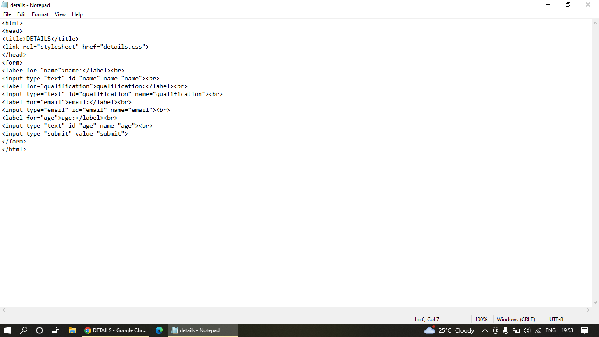

|  |
| --- |
|  |  |
|  |  |
|  | -name |
|  |  |
|  | -age |
|  |  |
|  | -submit button |
|  |  |

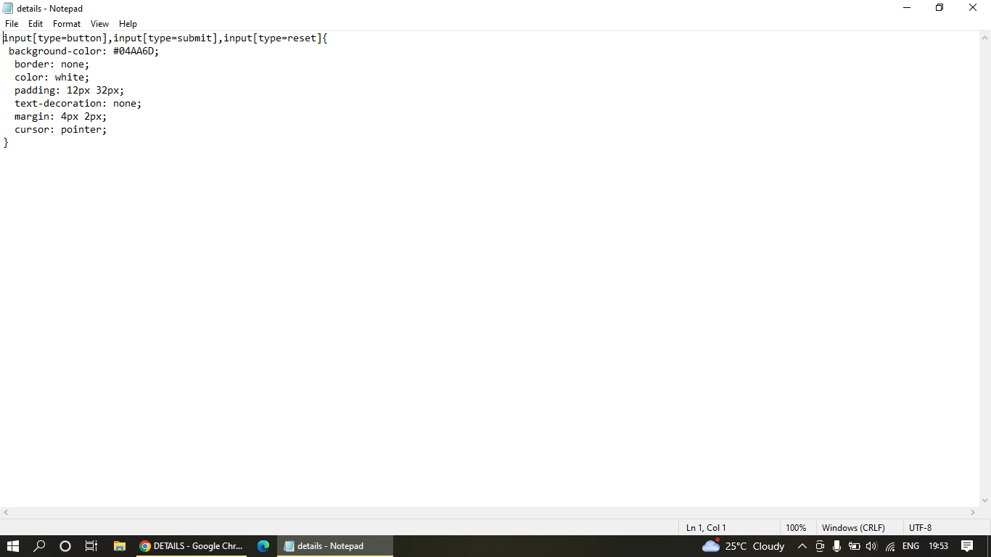

OUTPUT:

